Region 9 Championships &
This is a qualifying show for
2014 AQHA Novice Championships
East/West
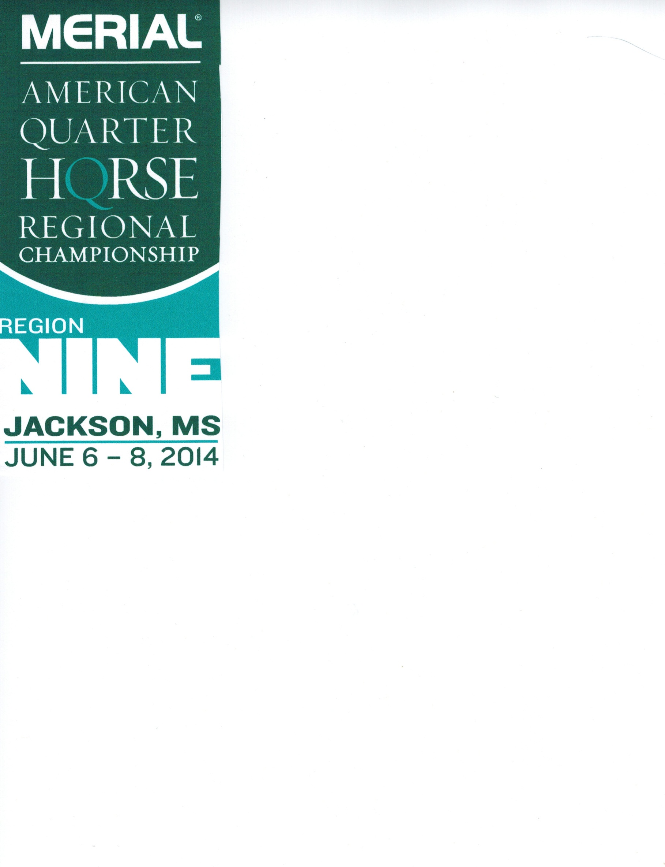
MQHA Summer Shows
Four sets of points
June 6 – 8, 2014
Kirk Fordice Equine Center
1207 Mississippi Street
Jackson, MS 39202
AQHA, MQHA & LQHA Approved
Judges: Carla Wennberg, Ryan Kail, Tom Robertson & John Pipkin
All 4 Judges in the arena at same time
Friday
Paid Trail Practice 8 am - 11:30 am
Show Starts -12 pm
1. Small Fry Trail 9. All Age Trail
2. Green Trail 10. Green Western Riding
3. Novice Amateur Trail 11. Novice Amateur Western Riding
4. Novice Youth Trail 13 & Under 12. Novice Youth Western Riding 13 & U
5. Novice Youth Trail 14 – 18 13. Novice Youth Western Riding 14-18
6. Select Trail 14. Amateur Western Riding
7. Amateur Trail 15. Youth Western Riding
8. Youth Trail 16. All Age Western Riding

Saturday - 7:30 am
17. Amateur Pleasure Driving
18. All Age Pleasure Driving
Saturday – 8 am
19. Amateur Yearling Stallions 34. Yearling Mares 50. Youth Yearling Mare
20. Amateur 2 Yr Old Stallions 35. 2 Yr Old Mares 51. Youth 2 Yr Old Mares
21. Amateur 3 Yr Old Stallions 36. 3 Yr Old Mares 52 Youth 3 Yr Old Mares
22. Amateur Aged Stallions 37. Aged Mares 53. Youth Aged Mares
23. Amateur Performance Stallions 38. Performance Mares 54. Youth Performance Mares
Grand & Reserve Amateur Stallions Grand & Reserve Mares Grand & Reserve Youth Mares
24. Yearling Stallions 39. Amateur Yearling Geldings 55. Youth Yearling Geldings
25. 2 Yr Old Stallions 40. Amateur 2 Yr Old Geldings 56. Youth 2 Yr Old Geldings
26. 3 Yr Old Stallions 41. Amateur 3 Yr Old Geldings 57. Youth 3 Yr Old Geldings
27. Aged Stallions 42. Amateur Ages Geldings 58. Youth Aged Geldings
28. Performance Stallions 43. Amateur Performance Geldings 59. Youth Performance Geldings
Grand & Reserve Stallions Grand & Reserve Amateur Geldings 60. Small Fry Showmanship
29. Amateur Yearling Mares 44. Yearling Geldings 61. Novice Amateur Showmanship
30. Amateur 2 Yr Old Mares 45. 2 Yr Old Geldings 62. Novice Youth Showmanship 13 & U
31. Amateur 3 Yr Old Mares 46. 3 Yr Old Geldings 63. Novice Youth Showmanship 14-18
32. Amateur Aged Mares 47. Aged Geldings 64. Select Showmanship
33. Amateur Performance Mares 48. Performance Geldings 65. Amateur Showmanship
Grand & Reserve Amateur Mares 49. Grand & Reserve Geldings 66. Youth Showmanship

Warning: Under Mississippi Law, an equine activity or sponsor is not liable for an injury to or the death of a participant in equine activities resulting from the inherent risks of equine activities pursuant to the act.
Break
67. Small Fry Hunter Under Saddle 75. All Age Hunter Under Saddle
68. Green Hunter Under Saddle 76. Small Fry Hunt Seat Equitation
69. Novice Amateur Hunter Under Saddle 77. Novice Amateur Hunt Seat Equitation
70. Novice Youth Hunter Under Saddle 13 & U 78. Novice Youth Hunt Seat Equitation 13 & U
71. Novice Youth Hunter Under Saddle 14-18 79. Novice Youth Hunt Seat Equitation 14-18
72. Select Hunter Under Saddle 80. Select Hunt Seat Equitation
73. Amateur Hunter Under Saddle 81. Amateur Hunt Seat Equitation
74. Youth Hunter Under Saddle 82. Youth Hunt Seat Equitation

Break
83. Lead Line 6 & Under 92. Youth Western Pleasure
84. Small Fry Walk-Trot 93. Senior Western Pleasure
85. Green Western Pleasure 94. Small Fry Horsemanship
86. Novice Amateur Western Pleasure 95. Novice Amateur Horsemanship
87. Novice Youth Western Pleasure 13 & U 96. Novice Youth Horsemanship 13 & U
88. Novice Youth Western Pleasure 14-18 97. Novice Youth Horsemanship 14-18
89. Junior Western Pleasure 98. Select Horsemanship
90. Select Western Pleasure 99. Amateur Horsemanship
91. Amateur Western Pleasure 100. Youth Horsemanship

Exhibitors Party!

Sunday – 8 am
101. Amateur Ranch Pleasure 115. Amateur Tie Down Roping 130. Amateur Barrels
102. Youth Ranch Pleasure 116. Youth Tie Down Roping 131. Youth Barrels
103. Ranch Pleasure 117. All Age Tie Down Roping 132. All Age Barrels
104. Novice Amateur Reining 118. Amateur Breakaway 133. Novice Amateur Poles
105. Novice Youth Reining 13 & U 119. Youth Breakaway 134. Novice Yth Poles 13 & U
106. Novice Youth Reining 14-18 120. Amateur Heading 135. Novice Yth Poles 14-18
107. Amateur Reining 121. Youth Heading 136. Select Poles
108. Youth Reining 122. All Age Heading 137. Amateur Poles
109. All Age Reining 123. Amateur Heeling 138. Youth Poles
110. Amateur Working Cowhorse 124. Youth Heeling 139. All Age Poles
111. Youth Working Cowhorse 125. All Age Heeling 140. Novice Amateur Stakes
112. All Age Working Cowhorse 126. Novice Amateur Barrels 141. Novice Yth Stakes 13&U
113. Amateur Boxing 127 Novice Youth Barrels 13 & U 142. Novice Yth Stakes 14-18
114. Youth Boxing 128. Novice Youth 14-18 143. Amateur Stakes
129. Select Barrels 144. Youth Stakes

Fees & Awards
Region Classes $35.00 per class
Office Fee $10.00 per horse (1 time fee)
Late Fee $20.00 per horse (1 time fee)
Flat Fee $200.00 (Region Classes only, this includes 1 stall & Office fee) Cattle charges are not included

Residents from all states may show in Region 9.

AQHA Fees AQHA Classes $15.00/per class/per judge
AQHA Fee $ 5.00/per horse/per judge
Office Fee $10.00/per horse
Late Fee $20.00/per horse (1 time fee)
Paid Trail Practice Fee $10.00 (This is not a mandatory fee)

Flat Fee for AQHA Classes is $200 per horse (includes 1 stall, AQHA & Office Fee) Cattle Charges are not included. Entries must be postmarked by May 15th or add $20.00 late fee.

*Best Value* Flat Fee for Both AQHA & Region Show is $300 per horse (includes 1 stall, AQHA & Office Fee) Cattle charges are not included. Entries must be postmarked by May 15th or add $20.00 late fee.

Cattle Fees $25.00/per run Working Cowhorse, Boxing
$15.00 per run in Tie Down Roping, Breakaway, Heading, Heeling

Stalls $75.00 for the show & must be prepaid. For reservations please contact, Pat Kress, 8704 Aragon Lane, Knoxville, TN 37923-5801, 865-384-5055. Those wishing to show out of their trailers may do so for $10.00 per horse. No tie outs!

Shavings S & S Shavings will be available for purchase at $6.00 a bag with a portion of each bag going to the Multiple Sclerosis Society.

Region Class Awards
All Around Buckles for Region 9 will be awarded in the following divisions: Novice Youth 13 & Under, Novice Youth 14 -18, Novice Amateur & Select Amateur. Buckle, pad & blanket will be awarded in each of the following Region 9 classes: Showmanship, Hunter Under Saddle, Hunt Seat Equitation, Western Pleasure, Horsemanship, Trail, Barrels, Poles, in only the Novice Youth 13 & Under, Novice Youth 14 -18, Novice Amateur, Select Amateur divisions.
Other Region Class awards will be announced.

Photographer Sally Blackwell 985-517-3787

Hotels: Comfort Inn – 601-352-8282
Best Western Executive Inn – 601-969-6555
Coliseum Inn & Suites – 601-352-8282
Days Inn – Coliseum – 601-352-7387
Hampton Inn & Suites – 601-352-1700
Holiday Inn Express – 601-948-4466
Red Roof Inn – Fairgrounds – 601-969-5006
Hilton Garden Inn – Jackson – 601-353-5464
Jackson Marriot – Downtown – 601-969-5100
Studio 6 – Jackson – 601-355-3599

For More Information please go to our web site: www.mqha.org or call Tommy Andrus
662-207-9358.

This show is brought to you by our following sponsors:
